**IKEA Gateway Changes**

1. In Workbench go to Tools > Talent Gateways
2. Select Edit for the gateway that you would like to amend
3. Scroll down to the bottom of the page and make sure that the “Hide search openings and featured jobs” and Disable progress bar settings are checked (see below)

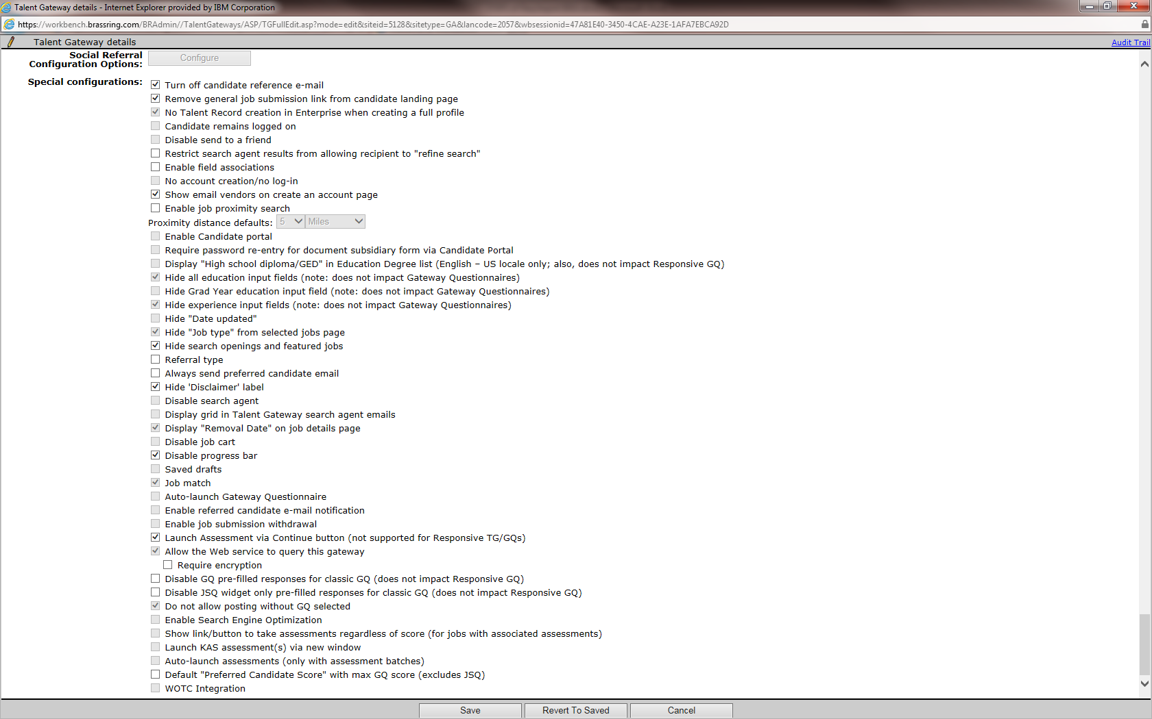

1. Save the screen
2. Now click the Text customization option
3. For the field Welcome page title add the following: <font color=ffffff>Welcome</font>

This makes sure that no text appears on the page as some text needs to be added and this will be invisible.

Please note: These settings have been changed on the English (Intl) external gateway.